Effect of Traffic and Soil Characteristics on Flexible and Rigid pavement Life Cycle Costs
Ibrahim Ramadanª, Alaa Ahmed^{b}, and Mohamed Zidan^{c*}
ªAssociate Prof., Civil Engineering Department, Faculty of Engineering at Shoubra, Benha University, Egypt
Email: Ibrahim.ramadan@feng.bu.edu.eg
^{b}Assisstant Prof., Civil Engineering Department, Faculty of Engineering at Shoubra, Benha University, Egypt
Email: alaa.ahmed@feng.bu.edu.eg
^{c*}Demonstrator, Civil Engineering Department, Faculty of Engineering at Shoubra, Benha University, Egypt
Email: muhammed.ali@feng.bu.edu.eg
Abstract: It is typically very difficult for the designer to select a suitable type of pavement while constructing a new road in Egypt because there are various types available, including flexible, rigid, and mixed pavement. Two models of structure design: one for flexible pavement and the other for rigid pavement are presented in this paper. This study aims to determine the suitable pavement type based on soil and traffic parameters; therefore, as expected, the authors performed nearly 1050 runs using various traffic and soil parameters. Design software is provided with a traffic and soil value for each run to determine the appropriate thickness of both flexible and rigid pavement. Accordingly, for each run, an estimate of the life cycle cost (LCC) was calculated for both rigid and flexible pavement. The LCC contains both construction and maintenance costs. Then the chart is designed to show the LCC for both types of pavement. It can be used to calculate the best pavement type based on soil type and traffic volume. It can be concluded that when CBR < 9% and ESAL > 110 (msa), the rigid pavement is preferred, and, the flexible pavement is preferred in the cases of CBR ≥ 10% and ESAL ≤ 50 (msa), and in cases where ESAL falls within the range of 50 to 110, the CBR value surpasses 10%.
Keywords: Rigid pavement; Flexible pavement; Equivalent Single Axle Load (ESAL); Life Cycle Cost (LCC); California Bearing Ratio (CBR).

INTRODUCTION
Flexible pavements and rigid pavements are the two major types of pavement used in road networks. Flexible pavements are more commonly used than rigid pavements because of their many advantages: low initial cost, good resistance to temperature variation, ease of maintenance work, and ease of detecting subsurface works (pipe locations).
In the assessment of the three types of pavement, flexible, rigid, and composite, considerations should include vehicle loads, soil capacity, and construction and maintenance costs to determine which type of paving is appropriate for these kinds of situations[1].
The road's pavement serves as the actual surface that vehicles will travel on;
it folds, causes friction for the vehicles, and transfers normal stresses to the subsurface soils[2].
Since there are many different types of pavement, including flexible, rigid,
and mixed pavement, it can be difficult for road designers in Egypt to select
the best kind when constructing a new road.
The authors noted that flexible pavement isn't always the best choice in some situations. Rigid pavement is preferred [3, 4], as it depends on the characteristics of the soil and the flow of traffic.
This research presents two structural design models, one for flexible pavement and the other for rigid pavement. These models help the pavement designer choose the type of pavement based on soil and traffic characteristics while taking the total cost, including construction and maintenance costs, into account.
The objective of this study will be able to determine the following conclusions from the definition of the previous problem:
- Compute the variation in the LCC of the flexible pavement for every run with varying traffic and soil conditions.
- Compute the variation in the LCC of the rigid pavement for every run with varying traffic and soil conditions.
- Throughout the pavement's lifespan, make comparisons between rigid and flexible pavement.
- Provide a clear process for selecting the type of pavement. This can be achieved by creating a chart with two zones: one for flexible pavement and the other for rigid pavement. Based on traffic load and soil conditions, the most suitable type of pavement can be selected.
By designing these types of pavements using pavement-design software, their equations ,and parameters are taken from the AASHTO Guide for the Design of Pavement Structures, 1993[5]. The authors will be able to determine the LCC for each type of pavement according to different values of traffic and soil.

LITERATURE REVIEW
A highway pavement's primary function is to distribute applied vehicle loads to the subgrade. The construction of highway pavement is made up of layers of processed materials layered on top of the underlying natural soil subgrade. Good riding conditions, sufficient skid resistance, decent light-reflecting properties, and minimal noise pollution should all be provided by the pavement construction. The ultimate objective is to make sure that the transmitted stresses caused by wheel load are appropriately reduced so as not to exceed the bearing capacity of the subgrade [6].
The American Concrete Pavement Association states that concrete pavements are preferred to asphaltic pavements due to their increased safety, durability, smoothness, flexibility, and cost-effectiveness. Because concrete never ruts, it provides the highest traction grip, increases visibility, and reduces wet spray in terms of safety. Rigid pavement is easier to keep its shape against traffic and challenging environmental conditions than flexible pavement[4, 7]. Compared to bituminous pavement, concrete pavement has benefits. A few of these are that it can be constructed in poor soil conditions, has a longer useful life, requires less aggregate and no flame, is less expensive to maintain, provides good visibility for nighttime driving, and is essentially unaffected by weather and temperature [2]. Flexible pavements are preferred over rigid roadways because of their major advantage of being able to be gradually strengthened and enhanced as traffic grows and because their surfaces may be recycled for reconstruction[4, 6]. The American Pavement Association (APA) states that there are several advantages of asphalt pavements over concrete pavements, such as reduced initial cost, lower maintenance costs, flexibility during construction, quick completion, the ability to support heavy loads, a long lifespan, and complete recyclability [1].
There are two methods for designing rigid pavement: the Portland Cement Association (PCA) and the AASHTO Design Method, which were used for designing the thickness-design procedure for concrete pavement. With additional adjustments based on theory and experience, the design process is based on the empirical data from the AASHTO Road Test [2, 3].
Based on past experience, the empirical pavement design methodologies for flexible pavement can be used to test the subgrade and pavement materials in a lab or on-site. For many years, the empirical methods of pavement design have been important for determining the thickness of the pavement structure. The main benefit of the empirical method is that the design process is very simple and quick to complete. The total number of equivalent standard axle loads, the traffic volume, and the strength of the subgrade soil are all calculated using the Transport Research Laboratory (TRL) method. The AASHTO Design Method and the CBR Method, use design curves for CBR, wheel load, and thickness to illustrate the pavement design process. In the pavement thickness design process, the AASHTO model's function is to determine the necessary structural number (SN)[2, 3].
In the assessment of the three types of pavement, flexible, rigid, and composite, considerations should include vehicle loads, soil capacity, and construction and maintenance costs to determine which type of paving is appropriate for these kinds of situations [1].
The initial cost is the expense of constructing a pavement. This cost is mostly determined by the thickness of the pavement, which is determined by the strength of the subgrade soil, traffic volume, and material costs [2].
Although it is important to make sure that two types of pavement are created for the same characteristics in order to compare their costs, rigid pavement requires twice as long to design as flexible pavement [2, 8, 9]. Although concrete normally lasts longer and requires less maintenance, asphalt usually costs more in the beginning [3, 10]. Rigid pavements are 39.4% less expensive than flexible pavements in terms of cost and save 62% on maintenance and repairs throughout their service life [4, 11].
Complete-depth repairs, partial-depth repairs, and resealing joints to improve performance are the most common maintenance and rehabilitation techniques
for concrete pavements. To maintain a sufficient level of service, Hot Mix Asphalt (HMA) pavements may need a more thorough maintenance plan than PCC
(rigid pavement) pavements. In a few countries, rigid pavements are being used more frequently. This is because they are low-maintenance and durable, which lowers total costs [2, 12].
Construction, rehabilitation, and maintenance costs are broken down into individual costs over thirty years period using the LCC analysis. Road construction costs are included in the starting costs of the comprehensive LCC analysis, as well as the cost of maintenance and use (renovation, repair, replacement, maintenance, reconstruction, and restoration)[13]. After twenty years, the life cycle cost of flexible pavement will be approximately 19% higher than that of rigid pavement [10, 14]. In comparison with rigid pavements, flexible pavements require costly, regular periodic maintenance, which increases their life cycle costs [14]. Rigid pavement will be more sustainable because its environmental impact is minimal and its cost is much cheaper than that of bitumen, considering that bitumen's changes in price and manufacturing process effect on the environment[2].
The life of the flexible pavement is nearing 15 years]5,16[. It has a low initial cost, but after a while, it requires regular maintenance, which is highly expensive. Rigid pavement has a far longer lifespan than flexible pavement-about 40 years-and is around 2.5 times more durable than flexible pavement, which has a much higher initial cost but a lot lower maintenance cost [2, 3, 6, 10, 14].
Road maintenance does not involve shoulder construction, widening, or rehabilitation. The process known as "rehabilitation" is applied to more than 25% of a road, and the average maintenance costs for one km of different types of currently accessible roads are used to estimate the costs of road maintenance [15].

DATA ANALYSIS AND RESULTS
Several factors, including traffic volume, soil conditions, and life cycle cost, must be analyzed to choose the best type of pavement. To choose a type of pavement, the following data analysis may be necessary:
Traffic Volume Analysis: To choose the appropriate pavement type, this process analyses traffic data such as axle loads, vehicle types, and traffic volume. Transportation agencies may provide traffic surveys, traffic counts, and traffic volume data that contain this information.
Soil Conditions: The term "soil bearing capacity" describes the soil's ability to sustain traffic loads and the weight of pavement. Compaction, soil type, and moisture content all have an impact. It is necessary to evaluate the load-bearing capacity to make sure the pavement can sustain the anticipated traffic loads without suffering from serious deformation or failure.
Life Cycle Cost (LCC) Analysis: In this analysis, the whole pavement life cycle including construction, maintenance, and rehabilitation is evaluated. Cost estimates, construction bids, and maintenance and rehabilitation records are good sources of
this information.
The authors used pavement design software to create around 1050 runs with various values for (ADT) and (CBR) to design both rigid and flexible pavement.
The authors assumed that (ADT from 1,000 to 70,000 veh/day and step each 1,000 veh/day) and (CBR from 4% to 18% and step each 1%) and designed each ADT value with a total range for CBR.
After determining the thickness of the flexible and rigid pavement, the construction cost was calculated based on the unified pricing list, as well as information regarding maintenance costs from the Ministry of Transportation through maintenance records.
The authors make a chart that depends on ESAL, CBR, and LCC to determine
the zones of flexible and rigid pavement, and this chart makes it easy for the designer to select the most suitable type of pavement.
Authors design according to the AASHTO Guide for the Design of Pavement Structures, 1993‏ ‏[5].

A SOFTWARE FOR DESIGNING FLEXIBLE AND RIGID PAVEMENT

Pavement design software has been developed to create two structural design models based on AASHTO equations and parameters: one for flexible pavement and another for rigid pavement. This software was created using the programming language C#, allowing for efficient processing of numerous runs. Using Excel for multiple runs would require significantly more time and effort, resulting in less accurate outcomes compared to the developed software.

STEPS FOR USING SOFTWARE TO DESIGN FLEXIBLE PAVEMENT
- Open the software and click on the flexible tab to display the interface used to design flexible pavement, as shown in Fig. 1.
- Insert the value for each parameter, like %T, PT, ADT, r, D, L, ZR, SO, and CBR, and then click Run, as shown in Fig. 1.
- The value of ESAL was obtained for each value of ADT.
- Modules of Resilience (MR) were calculated in software according to equations 5 and 6.
- Submit the values of ESAL (W18) and MR in Equation 1, and the designer will get the value of the structure number (SN).
- By assuming the values of a1, a2, and a3, the designer can calculate the thickness of each layer (t1, t2, and t3) from equations 7, 8, and 9.
- After getting the thickness of each layer, the designer can calculate the LCC as shown in Appendix A, which contains Tables 2, 3, 4, and 5.

STEPS FOR USING SOFTWARE TO DESIGN RIGID PAVEMENT
- Open the software and click on the rigid tab to display the interface used to design rigid pavement, as shown in Fig. 3.
- Insert the value for each parameter, like %T, PT, ADT, r, D, L, ZR, SO, E_{C}, cd, S_{c}, J, Ls, Subbase thickness (D_{SB}), and CBR , and then click Run, as shown in Fig. 3.
- The value of ESAL was obtained for each value of ADT.
- Modules of Resilience (MR) were calculated in software according to equations 5 and 6.
- Submit the value of ESAL (W18) in equation 5, and the designer will get the depth of the slab (D). This is calculated in the absence of a subbase, and k is calculated from equation 11.
- If using a subbase between subgrade and slab, k is calculated from the software according to Table 7. Then get the new depth, which is named "New depth" in the software interface.
- After getting the thickness of the slab, the designer can calculate the LCC as shown in Appendix B, which contains Tables 8, 9, and 10.

FLEXIBLE PAVEMENT
Equation (1) is illustrated. The flexible pavement design equation
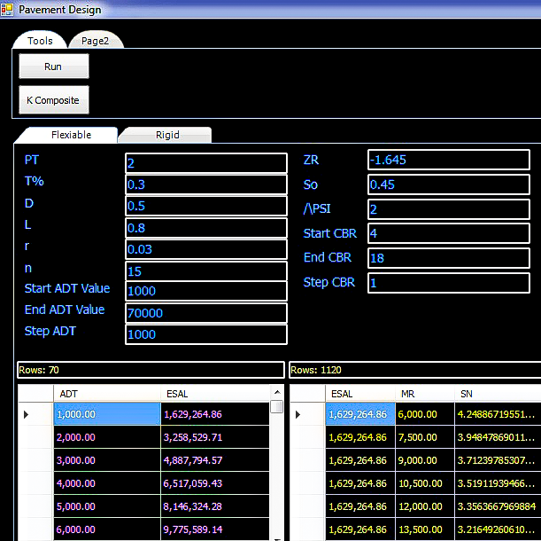
$\log{W18}=Zr*So+9.36*\log\left(SN+1\right)-0.2+\frac{\log\left[\frac{∆PSI}{4.2-1.5}\right]}{0.40+\frac{1094}{{\left(SN+1\right)}^{5.19}}}+2.32*\log{MR-8.07} ‏‏ ‏ ADDIN EN.CITE <EndNote><Cite><Author>Officials</Author><Year>1993</Year><RecNum>21</RecNum><DisplayText>[5]</DisplayText><record><rec-number>21</rec-number><foreign-keys><key app="EN" db-id="s2zprzxvwztvdfe0web5wea2200tv0rs0fpt" timestamp="1689709579">21</key></foreign-keys><ref-type name="Book">6</ref-type><contributors><authors><author>Transportation Officials</author></authors></contributors><titles><title>AASHTO Guide for Design of Pavement Structures, 1993</title></titles><volume>1</volume><dates><year>1993</year></dates><publisher>Aashto</publisher><isbn>1560510552</isbn><urls></urls></record></Cite></EndNote>[5]$ (1)

FIGURE 1. The software interface used to design flexible pavement

Authors assumed these parameters in designing flexible pavement according to [5]:
ESAL: Equivalent Single Axle Load (msa) million standard axles; its value from equation (2)
$Cumulative ESAL \left( W18 \right)= \%T * PT *ADT* D.D *365*L.D* GF$ ]16[ (2)
Where:
ADT: Average Daily Traffic and its value from 1,000 to 70,000 veh/day and step
each 1,000 veh/day.
PT: Truck Factor; Its value =2.
%T: percent of trucks, its value = 30%.
L.D.: Lane distribution = 0.8 (three lanes or more) per direction.
D.D.: Directional distribution = 0.5.
GF: Growth Factor, its value is taken from equation (3).
$GF=\frac{{\left(1+r\right)}^{n}-1}{r}$ ]16[ (3) Where:
n: Design period; its value is 15 years. r: traffic growth rate Its value is 3%.
So: over the standard deviation, its value is 0.45.
Zr: factor depends on Design Reliability (R); if we take R = 95%, then Zr = -1.645.
SN: Structure Number.
∆PSI: Design serviceability loss $∆PSI =pi-pt$ ]16[ (4) where:
Pi: initial present serviceability; its value is 4.
Pt: Terminal present serviceability its value is 2.
MR: Modulus of Resilience of subgrade, its value is taken from the equation 5,6.
If CBR ≥10% $MR=4920*(CBR)^0.48$ ]16[ (5)
If CBR <10% $MR=1500*CBR$ ]16[ (6)
Authors input these values into the software. D.D, PT, n, %T, L.D., r, start CBR, and end CBR, start ADT, end ADT, ∆psi, Zr, So, then click Run to get MR corresponding to each CBR value and W18 corresponding to each ADT value.
Equation (1) above provides the SN value, while the following equations provide
the thickness of each layer:
$SN1=t1*a1$] 16[ (7)
$SN2=t1*a1+a2*m2*t2$]16[ (8)
$SN3=t1*a1+a2*m2*t2+a3*m3*t3$] 16[ (9) Where:
t1: Surface layer thickness (inch). t2: Base layer thickness (inch).
t3: Subbase layer thickness (inch).
m2: Base layer drainage coefficient assumed its value =1.
m3: Subbase layer drainage coefficient assumed its value =1.
a1: Asphalt layer coefficient, assume Mr. Asphalt = 400,000 psi, then a1 =0.42
a2: Base layer coefficient: assume CBR base = 80%, then a2 = 0.135.
a3: Subbase layer coefficient: assume CBR subbase = 30%, then a2 = 0.11.
Using Table 1's layer thicknesses, authors can categorize the variety of designs by SN.
TABLE 1.The variety of designs by SN including layer thicknesses
Model name | SN |  | Layer thicknesses
 | from | to | t1(cm) | t2(cm) | t3(cm)
A | 7 | 7.35 | 18 | 45 | 45
B | 6.5 | 7 | 18 | 40 | 45
C | 6 | 6.5 | 16 | 40 | 40
D | 5.5 | 6 | 15 | 35 | 40
E | 5 | 5.5 | 15 | 30 | 35
F | 4.5 | 5 | 14 | 30 | 30
G | 4 | 4.5 | 14 | 20 | 25
H | 3.5 | 4 | 13 | 35 | 0
I | 3 | 3.5 | 12 | 30 | 0
J | 2.79 | 3 | 12 | 20 | 0
It should be noted that because the rigid pavement design period is 30 years, authors can calculate the construction and maintenance costs throughout
that time by designing each value of ESAL with MR, which gives a specific value for SN. Authors assumed that the two types have the same lifespan to compare them. The calculation of the (LCC) is shown in Appendix A, which contains Tables 2, 3, 4, and 5.
Then, as shown in the calculations in Table 6, the authors can draw Fig. 2 which illustrates the relationship between ESAL (msa) and LCC (million LE) at each value of CBR.
TABLE 6. Life Cycle Cost (million LE ) of flexible pavement section ( 1000m * 1 m )
for different soil and traffic conditions
CBR% | ESAL (msa)
 | 4.887 | 14.663 | 24.438 | 34.214 | 43.99 | 53.765 | 63.541 | 73.316 | 83.092 | 92.868 | 102.64 | 114
4 | 2.957 | 3.622 | 3.680 | 3.680 | 3.772 | 3.772 | 3.772 | 3.772 | 3.816 | 3.816 | 3.816 | 3.816
5 | 2.957 | 3.548 | 3.622 | 3.622 | 3.680 | 3.680 | 3.680 | 3.772 | 3.772 | 3.772 | 3.772 | 3.772
6 | 2.840 | 3.548 | 3.548 | 3.622 | 3.622 | 3.622 | 3.680 | 3.680 | 3.680 | 3.680 | 3.680 | 3.772
7 | 2.840 | 2.957 | 3.548 | 3.548 | 3.622 | 3.622 | 3.622 | 3.622 | 3.680 | 3.680 | 3.680 | 3.680
8 | 2.784 | 2.957 | 2.957 | 3.548 | 3.548 | 3.548 | 3.622 | 3.622 | 3.622 | 3.622 | 3.622 | 3.680
9 | 2.784 | 2.840 | 2.957 | 2.957 | 3.548 | 3.548 | 3.548 | 3.548 | 3.622 | 3.622 | 3.622 | 3.622
10 | 2.784 | 2.840 | 2.957 | 2.957 | 2.957 | 3.548 | 3.548 | 3.548 | 3.548 | 3.622 | 3.622 | 3.622
11 | 2.784 | 2.840 | 2.957 | 2.957 | 2.957 | 3.548 | 3.548 | 3.548 | 3.548 | 3.548 | 3.622 | 3.622
12 | 2.784 | 2.840 | 2.840 | 2.957 | 2.957 | 2.957 | 3.548 | 3.548 | 3.548 | 3.548 | 3.548 | 3.622
13 | 2.784 | 2.840 | 2.840 | 2.957 | 2.957 | 2.957 | 3.548 | 3.548 | 3.548 | 3.548 | 3.548 | 3.548
14 | 2.726 | 2.840 | 2.840 | 2.957 | 2.957 | 2.957 | 2.957 | 3.548 | 3.548 | 3.548 | 3.548 | 3.548
15 | 2.726 | 2.840 | 2.840 | 2.957 | 2.957 | 2.957 | 2.957 | 3.548 | 3.548 | 3.548 | 3.548 | 3.548
16 | 2.726 | 2.784 | 2.840 | 2.957 | 2.957 | 2.957 | 2.957 | 2.957 | 3.548 | 3.548 | 3.548 | 3.548
17 | 2.726 | 2.784 | 2.840 | 2.840 | 2.957 | 2.957 | 2.957 | 2.957 | 3.548 | 3.548 | 3.548 | 3.548
18 | 2.726 | 2.784 | 2.840 | 2.840 | 2.957 | 2.957 | 2.957 | 2.957 | 2.957 | 3.548 | 3.548 | 3.548
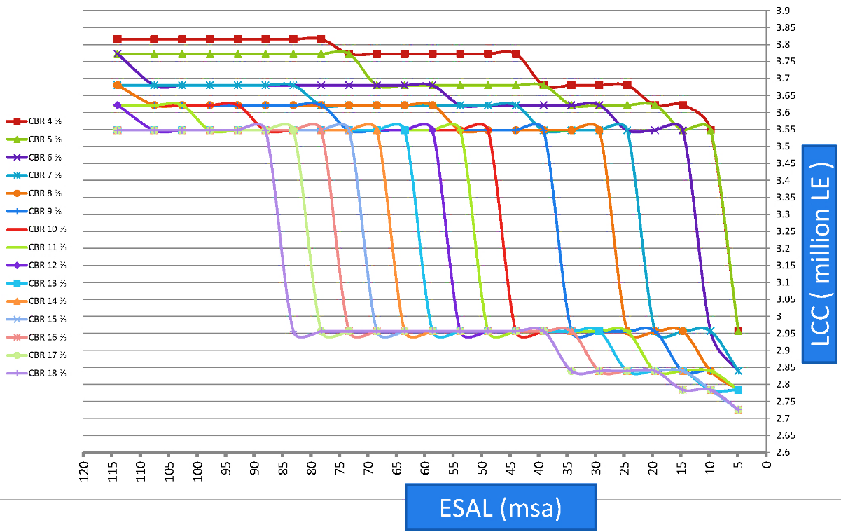

[

FIGURE 2. The relationship between LCC (million LE) and ESAL (msa) for flexible pavement at each value of CBR.

Rigid pavement
Equation (10) is illustrated. The rigid pavement design equation
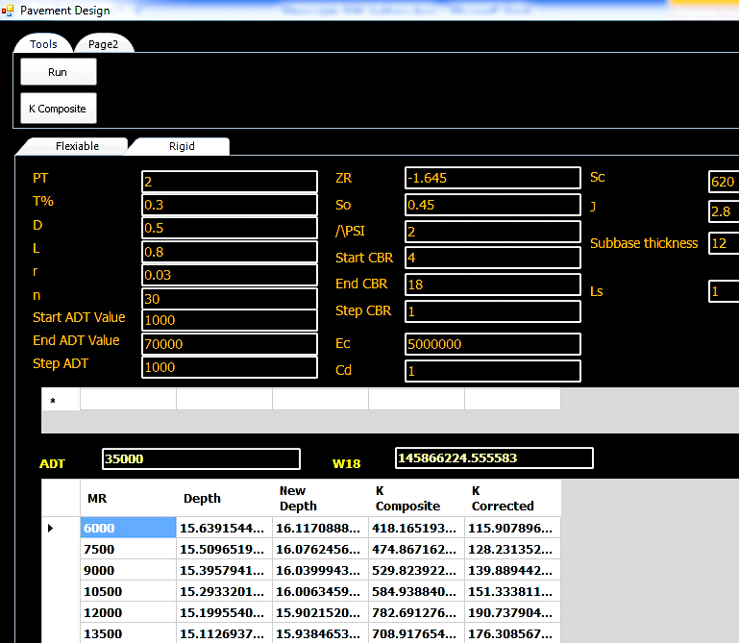
$\log{ESAL}=So*Zr+7.35*\log\left(D+1\right)-0.06+\frac{\log\left[\frac{∆PSI}{4.5-1.5}\right]}{1+\frac{1.624*10^7}{{\left(D+1\right)}^{8.46}}}+\left(4.22-0.32*Pt\right)*\log{*\left[\frac{Cd*SC^{'}*\left[D^{0.75}-1.132\right]}{215.63*J*\left[D^{0.75}-\frac{18.42}{\left({Ec}/k\right)^0.25}\right]}\right]} ‏ ADDIN EN.CITE <EndNote><Cite><Author>Officials</Author><Year>1993</Year><RecNum>21</RecNum><DisplayText>[5]</DisplayText><record><rec-number>21</rec-number><foreign-keys><key app="EN" db-id="s2zprzxvwztvdfe0web5wea2200tv0rs0fpt" timestamp="1689709579">21</key></foreign-keys><ref-type name="Book">6</ref-type><contributors><authors><author>Transportation Officials</author></authors></contributors><titles><title>AASHTO Guide for Design of Pavement Structures, 1993</title></titles><volume>1</volume><dates><year>1993</year></dates><publisher>Aashto</publisher><isbn>1560510552</isbn><urls></urls></record></Cite></EndNote>[5]$ (10)

FIGURE 3. The software's interface for designing rigid pavement
In designing rigid pavement, authors used these assumptions in accordance with [5]:
Authors could consider the common characteristics of both flexible and rigid pavement to be the same
n: number of years its value is 30 years D: Slab thickness (inch).
Cd: drainage coefficient its value is 1, J: Load transfer coefficient its value is 2.8.
Sc': Concrete modulus of rupture its value is 620 psi.
E_{c}: Concrete elastic modulus its value is 5*10^6 psi.
We assumed CBR subbase = 30%, then E_{SB} ≈ 30,000 psi from equation (5).
LS: Loss of Support; its value is 1. D_{SB}: subbase depth; its value is 12 inches.
K: The modulus of the subgrade reaction, which changes based on whether
a subbase layer is used in between the subgrade and the concrete slab or not.
When ESAL < 67 msa, in the absence of a subbase, K is calculated from equation (11)
$K=\frac{MR}{19.4} ADDIN EN.CITE <EndNote><Cite><Author>Officials</Author><Year>1993</Year><RecNum>21</RecNum><DisplayText>[5]</DisplayText><record><rec-number>21</rec-number><foreign-keys><key app="EN" db-id="s2zprzxvwztvdfe0web5wea2200tv0rs0fpt" timestamp="1689709579">21</key></foreign-keys><ref-type name="Book">6</ref-type><contributors><authors><author>Transportation Officials</author></authors></contributors><titles><title>AASHTO Guide for Design of Pavement Structures, 1993</title></titles><volume>1</volume><dates><year>1993</year></dates><publisher>Aashto</publisher><isbn>1560510552</isbn><urls></urls></record></Cite></EndNote>[5]$ (11)
When ESAL > 67 msa using a subbase, K composite is calculated from software
as shown in Table 7 and this design from the AASHTO charts [5].
TABLE 7. K composite while using a subbase
Thickness | MR | ESB | Log(X) | Log(Y) | K_{composite} | LS | K_{corrected}
12 | 4500 | 30,0000 | 0.79 | 1.13 | 348.74 | 1 | 100.34
12 | 6000 | 30,0000 | 0.88 | 1.13 | 418.17 | 1 | 115.91
12 | 7500 | 30,0000 | 0.95 | 1.13 | 474.87 | 1 | 128.23
12 | 9000 | 30,0000 | 1.01 | 1.13 | 529.82 | 1 | 139.89

Authors input these values into the software r, %T, D.D., PT, L.D., n, star ADT, end ADT, So, Zr, ∆psi, start CBR, and end CBR, LS , E_{c} , SC', J, Cd, D_{SB} then click Run to get W18 corresponding to each ADT value and MR corresponding to each CBR value. authors obtain the D value when there is
no subbase and Dnew when a subbase is used from equation (10) above.
The cost for construction and maintenance can be estimated for 30 years as shown in Appendix B, which contains Tables 8, 9, and 10 show how to calculate (LCC) to compare the two types.
Then, as shown in the calculations in Table 11, the authors can draw Fig. 4 which illustrates the relationship between ESAL (msa) and LCC (million LE) at each value of CBR.
TABLE 11. Life Cycle Cost (million LE ) of rigid pavement section ( 1000m * 1 m )
for different soil and traffic conditions
CBR% | ESAL (msa)
 | 4.18 | 29.17 | 54.18 | 79.18 | 104.19 | 129.19 | 154.2 | 179.21 | 204.21 | 229.22 | 254.22 | 291.73
4 | 2.680 | 3.080 | 3.398 | 3.358 | 3.358 | 3.398 | 3.533 | 3.533 | 3.533 | 3.643 | 3.643 | 3.698
5 | 2.680 | 3.080 | 3.155 | 3.398 | 3.358 | 3.398 | 3.398 | 3.533 | 3.533 | 3.643 | 3.643 | 3.643
6 | 2.680 | 3.080 | 3.155 | 3.398 | 3.358 | 3.398 | 3.398 | 3.533 | 3.533 | 3.533 | 3.643 | 3.643
7 | 2.680 | 3.080 | 3.155 | 3.398 | 3.358 | 3.358 | 3.398 | 3.533 | 3.533 | 3.533 | 3.643 | 3.643
8 | 2.680 | 2.990 | 3.155 | 3.398 | 3.358 | 3.358 | 3.398 | 3.398 | 3.533 | 3.533 | 3.643 | 3.643
9 | 2.680 | 2.990 | 3.155 | 3.398 | 3.358 | 3.358 | 3.398 | 3.398 | 3.533 | 3.533 | 3.533 | 3.643
10 | 2.680 | 2.990 | 3.155 | 3.398 | 3.358 | 3.358 | 3.398 | 3.398 | 3.533 | 3.533 | 3.533 | 3.643
11 | 2.680 | 2.990 | 3.155 | 3.398 | 3.358 | 3.358 | 3.398 | 3.398 | 3.533 | 3.533 | 3.533 | 3.643
12 | 2.680 | 2.990 | 3.155 | 3.398 | 3.358 | 3.358 | 3.398 | 3.398 | 3.533 | 3.533 | 3.533 | 3.643
13 | 2.680 | 2.990 | 3.155 | 3.398 | 3.398 | 3.358 | 3.398 | 3.398 | 3.533 | 3.533 | 3.533 | 3.643
14 | 2.680 | 2.990 | 3.155 | 3.398 | 3.398 | 3.358 | 3.398 | 3.398 | 3.398 | 3.533 | 3.533 | 3.643
15 | 2.680 | 2.990 | 3.155 | 3.398 | 3.398 | 3.358 | 3.398 | 3.398 | 3.398 | 3.533 | 3.533 | 3.643
16 | 2.680 | 2.990 | 3.155 | 3.398 | 3.398 | 3.358 | 3.398 | 3.398 | 3.398 | 3.533 | 3.533 | 3.643
17 | 2.680 | 2.990 | 3.155 | 3.398 | 3.398 | 3.358 | 3.398 | 3.398 | 3.398 | 3.533 | 3.533 | 3.643
18 | 2.680 | 2.990 | 3.155 | 3.398 | 3.398 | 3.358 | 3.398 | 3.398 | 3.398 | 3.533 | 3.533 | 3.533

FIGURE 4. The relationship between LCC (million LE) and ESAL (msa) at each CBR value for rigid pavement.
Then, as shown in the calculations in Table 12, authors can draw Figures 5 and 6 that illustrate the relationship between ESAL (msa) and LCC (million LE)
at each value of CBR to obtain two zones of flexible and rigid pavement
by defining which type is preferred: flexible (F) or rigid (R).
TABLE 12. The relationship between ESAL (msa) and LCC (million LE) at each value of CBR to determine which type is preferred
ESAL (msa) | CBR% | LCC ( F) | LCC ( R) | The preferred | ESAL (msa) | CBR% | LCC ( F) | LCC ( R) | The preferred
4.18 | 4 | 2.9566 | 2.6799 | R | 66.68 | 4 | 3.7725 | 3.3979 | R
16.67 | 4 | 3.6216 | 2.9899 | R | 79.18 | 4 | 3.8156 | 3.3579 | R
29.17 | 4 | 3.6801 | 3.0799 | R | 91.69 | 4 | 3.8156 | 3.3579 | R
41.68 | 4 | 3.7725 | 3.1549 | R | 104.19 | 4 | 3.8156 | 3.3579 | R
54.18 | 4 | 3.7725 | 3.3979 | R | 116.69 | 4 | 3.8156 | 3.3979 | R
4.18 | 6 | 2.8396 | 2.6799 | R | 66.68 | 6 | 3.6801 | 3.3979 | R
16.67 | 6 | 3.5477 | 2.9899 | R | 79.18 | 6 | 3.6801 | 3.3979 | R
29.17 | 6 | 3.6216 | 3.0799 | R | 91.69 | 6 | 3.6801 | 3.3579 | R
41.68 | 6 | 3.6216 | 3.1549 | R | 104.19 | 6 | 3.6801 | 3.3579 | R
54.18 | 6 | 3.6216 | 3.1549 | R | 116.69 | 6 | 3.7725 | 3.3579 | R
16.67 | 8 | 2.9566 | 2.9899 | F | 79.18 | 8 | 3.6216 | 3.3979 | R
29.17 | 8 | 3.5477 | 2.9899 | R | 91.69 | 8 | 3.6216 | 3.3979 | R
41.68 | 8 | 3.5477 | 3.0799 | R | 104.19 | 8 | 3.6216 | 3.3579 | R
54.18 | 8 | 3.5477 | 3.1549 | R | 116.69 | 8 | 3.6801 | 3.3579 | R
66.68 | 8 | 3.6216 | 3.3979 | R | 16.67 | 10 | 2.8396 | 2.9899 | F
29.17 | 10 | 2.9566 | 2.9899 | F | 91.69 | 10 | 3.6216 | 3.3979 | R
41.68 | 10 | 2.9566 | 3.0799 | F | 104.19 | 10 | 3.6216 | 3.3579 | R
54.18 | 10 | 3.5477 | 3.1549 | R | 116.69 | 10 | 3.6216 | 3.3579 | R
66.68 | 10 | 3.5477 | 3.1549 | R | 16.67 | 12 | 2.8396 | 2.9899 | F
79.18 | 10 | 3.5477 | 3.3979 | R | 29.17 | 12 | 2.9566 | 2.9899 | F
41.68 | 12 | 2.9566 | 3.0799 | F | 104.19 | 12 | 3.5477 | 3.3579 | R
54.18 | 12 | 2.9566 | 3.1549 | F | 116.69 | 12 | 3.6216 | 3.3579 | R
66.68 | 12 | 3.5477 | 3.1549 | R | 4.18 | 14 | 2.7257 | 2.6799 | R
79.18 | 12 | 3.5477 | 3.3979 | R | 16.67 | 14 | 2.8396 | 2.9899 | F
91.69 | 12 | 3.5477 | 3.3979 | R | 29.17 | 14 | 2.8396 | 2.9899 | F
41.68 | 14 | 2.9566 | 3.0799 | F | 104.19 | 14 | 3.5477 | 3.3979 | R
54.18 | 14 | 2.9566 | 3.1549 | F | 116.69 | 14 | 3.5477 | 3.3579 | R
66.68 | 14 | 3.5477 | 3.1549 | R | 16.67 | 16 | 2.7842 | 2.9899 | F
79.18 | 14 | 3.5477 | 3.3979 | R | 29.17 | 16 | 2.8396 | 2.9899 | F
91.69 | 14 | 3.5477 | 3.3979 | R | 41.68 | 16 | 2.9566 | 3.0799 | F
54.18 | 16 | 2.9566 | 3.1549 | F | 116.69 | 16 | 3.5477 | 3.3579 | R
66.68 | 16 | 2.9566 | 3.1549 | F | 16.67 | 18 | 2.7842 | 2.9899 | F
79.18 | 16 | 3.5477 | 3.3979 | R | 29.17 | 18 | 2.8396 | 2.9899 | F
91.69 | 16 | 3.5477 | 3.3979 | R | 41.68 | 18 | 2.9566 | 3.0799 | F
104.19 | 16 | 3.5477 | 3.3979 | R | 54.18 | 18 | 2.9566 | 3.1549 | F
66.68 | 18 | 2.9566 | 3.1549 | F | 104.19 | 18 | 3.5477 | 3.3979 | R
79.18 | 18 | 2.9566 | 3.3979 | F | 116.69 | 18 | 3.5477 | 3.3579 | R
91.69 | 18 | 3.5477 | 3.3979 | R | > 114 | Rigid is preferred

FIGURE 5. The relationship between ESAL (msa) and LCC (million LE at each value of CBR to obtain two zones of flexible and rigid pavement

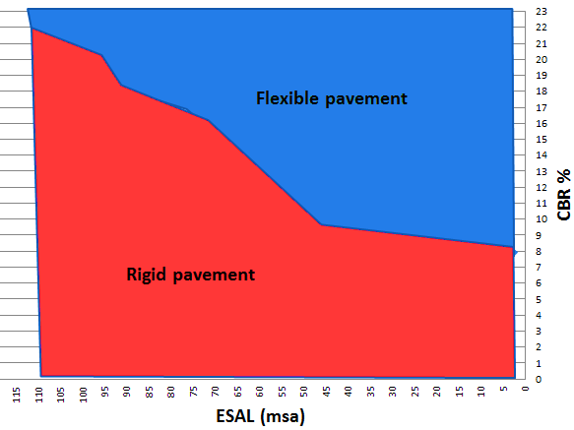
Finally, the generated chart in Fig. 6 can be used by the designer to evaluate whether the designer may use the flexible or rigid pavement when the designer
has specific traffic characteristics in terms of ESAL (msa) and soil characteristics
in terms of CBR%.

FIGURE 6. The relationship between CBR% and ESAL (msa) when considering LCC
to select pavement type

CONCLUSIONS AND RECOMMENDATIONS
Because the objective of this paper is to help designers choose pavement types based on traffic and soil characteristics while considering the total costs, which include construction and maintenance, the authors established a clear methodology for choosing a pavement type. Finally, the generated chart in this study can be used by the designer to evaluate whether to use the flexible or rigid pavement when there are specific traffic characteristics in terms of ESAL (msa) and soil characteristics in terms of CBR%.
In the study of developing a clear methodology for choosing a pavement type, authors can note the following points:
- Rigid pavement is recommended regardless of ESAL value when CBR
is less than 9%.
- Rigid pavement is recommended regardless of CBR value when ESAL
is more than 110 (msa).
- Flexible pavement is recommended when the ESAL is less than 50 (msa) and the CBR value is greater than 10%.
- If the (ESAL) falls within the range of 50 to 110, and the (CBR) value
surpasses 10, the preference will be given to the flexible pavement.

The authors recommended the following:

- When selecting the type of pavement, the authors advise using values obtained from this research.
- The environmental impact of the project may be included in the LCC study
at each stage.
- When comparing various pavement types, composite pavement may be taken
into consideration.

ACKNOWLEDGMENT
Thanks are due to the Roads Laboratory and the Library of the Faculty of Engineering in Shubra for their support and valuable resources. It highlights the library's wide range of materials, its conducive study environment, and the dedication of its staff. The author also extends his thanks to the college for providing access to this rich library of resources.

REFERENCES
[1] M. Arifuzzaman Bhuyan, "Evaluation of flexible and rigid pavements construction in Bangladesh," 2009.
[2] D. A. Manuka and M. M. Kuleno, "SUITABILITY AND COST-WISE COMPARATIVE ANALYSIS OF RIGID AND FLEXIBLE PAVEMENTS: A REVIEW," International Journal of Engineering Applied Sciences and Technology, vol. 09
2019.
[3] E. A. M. Taha, K. A. Yousef, and O. Y. A. Ibrahim, "Comparative Design of Rigid and Flexible Pavement," Sudan University of Science and Technology, 2017.
[4] I. Skrzypczak, W. Radwański, and T. Pytlowany, "Durability vs technical-the usage properties of road pavements," in E3S web of conferences, 2018, vol. 45: EDP Sciences, p. 00082.
[5] T. Officials, AASHTO Guide for Design of Pavement Structures, 1993. Aashto, 1993.
[6] S. Jain, Y. Joshi, and S. Goliya, "Design of rigid and flexible pavements by various methods & their cost analysis of each method," International Journal of Engineering Research and Applications, vol. 3, no. 5, pp. 119-123, 2013.
[7] S. A. Taher, S. Alyousify, and H. J. A. Hassan, "Comparative study of using flexible and rigid pavements for roads: A review study," Journal of Duhok University, vol. 23, no. 2, pp. 222-234, 2020.
[8] M. Pourgholamali, S. Labi, and K. C. Sinha, "Multi-objective optimization in highway pavement maintenance and rehabilitation project selection and scheduling: A state-of-the-art review," Journal of Road Engineering, 2023.
[9] J. Tong, T. Ma, K. Shen, H. Zhang, and S. Wu, "A criterion of asphalt pavement rutting based on the thermal-visco-elastic-plastic model," International Journal of Pavement Engineering, vol. 23, no. 4, pp. 1134-1144, 2022.
[10] M. V. Mohod and K. Kadam, "A comparative study on rigid and flexible pavement: A review," IOSR Journal of Mechanical and Civil Engineering (IOSR-JMCE), vol. 13, no. 3, pp. 84-88, 2016.
[11] A. Yavuz, "A Relative Assessment of the Life-Cycle Costs of Rigid and Flexible Pavement Coatings in Turkey," Avrupa Bilim ve Teknoloji Dergisi, no. 18, pp. 918-926, 2020.
[12] A. Nautiyal and S. Sharma, "Condition Based Maintenance Planning of low volume rural roads using GIS," Journal of Cleaner Production, vol. 312, p. 127649, 2021.
[13] A. Kristowski, B. Grzyl, M. Kurpińska, and M. Pszczoł, "The rigid and flexible road pavements in terms of life cycle costs," in Creative Construction Conference 2018, 2018: Budapest University of Technology and Economics, pp. 226-233.
[14] O. F. Hamim, S. S. Aninda, M. S. Hoque, and M. Hadiuzzaman, "Suitability of pavement type for developing countries from an economic perspective using life cycle cost analysis," International Journal of Pavement Research and Technology, vol. 14, pp. 259-266, 2021.
[15] S. Burningham and N. Stankevich, "Why road maintenance is important and how to get it done," 2005.
]16[ Egyptian Code of Practice (ECP), Urban and rural roads, edition 2: Structural design of roads (part six). Ministry of Housing, Utilities and Urban Communities. Cairo, Egypt, 2020.

Appendix A
The construction and maintenance cost for flexible pavement
TABLE 2.The construction cost for flexible pavement
Model name | SN | Subbase  (cm) | price  (m3) | Base  (cm) | price  (m3) | Price (m2) MC30 | Binder course  (cm) | price (m2) | Price (m2) RC3000
A | 7 to 7.35 | 45 | 200 | 45 | 280 | 42 | 6 | 165 | 20
B | 6.5 to 7 | 45 | 200 | 40 | 280 | 42 | 6 | 165 | 20
C | 6 to 6.5 | 40 | 200 | 40 | 280 | 42 | 6 | 165 | 20
D | 5.5 to 6 | 40 | 200 | 35 | 280 | 42 | 5 | 160 | 20
E | 5 to 5.5 | 35 | 200 | 30 | 280 | 42 | 5 | 160 | 20
F | 4.5 to 5 | 30 | 200 | 30 | 280 | 42 | 7 | 170 | 20
G | 4 to 4.5 | 25 | 200 | 20 | 280 | 42 | 7 | 170 | 20
H | 3.5 to 4 | 0 | 200 | 35 | 280 | 42 | 7 | 170 | 20
I | 3 to 3.5 | 0 | 200 | 30 | 280 | 42 | 6 | 165 | 20
J | 2.79 to 3 | 0 | 200 | 20 | 280 | 42 | 6 | 165 | 20

TABLE 3.The construction cost for flexible pavement ( Cont.)
Model name | SN | Wearing course  (cm) | price (m2) | Price (m2) RC3000 | Wearing course02(cm) | price (m2) | Assumed length(m) | Assumed width(m)
A | 7 to 7.35 | 6 | 180 | 22 | 6 | 200 | 1000 | 1
B | 6.5 to 7 | 6 | 180 | 22 | 6 | 200 | 1000 | 1
C | 6 to 6.5 | 5 | 170 | 22 | 5 | 190 | 1000 | 1
D | 5.5 to 6 | 5 | 170 | 22 | 5 | 190 | 1000 | 1
E | 5 to 5.5 | 5 | 170 | 22 | 5 | 190 | 1000 | 1
F | 4.5 to 5 | 7 | 190 | 0 | 0 | 0 | 1000 | 1
G | 4 to 4.5 | 7 | 190 | 0 | 0 | 0 | 1000 | 1
H | 3.5 to 4 | 6 | 180 | 0 | 0 | 0 | 1000 | 1
I | 3 to 3.5 | 6 | 180 | 0 | 0 | 0 | 1000 | 1
J | 2.79 to 3 | 6 | 210 | 0 | 0 | 0 | 1000 | 1

TABLE 4.The construction cost for flexible pavement ( Cont.)
Model name | SN | Total Construction cost 1st 15 years | Total  Construction cost 2nd 15 years | Total Construction cost 30 years | Total maintenance cost 30 years | Life cycle cost (LCC ) 30 years
A | 7 to 7.35 | 845,400 | 1,756,694.31 | 2,601,694 | 1,213,898.24 | 3,815,593
B | 6.5 to 7 | 831,000 | 1,727,589.32 | 2,558,589 | 1,213,898.24 | 3,772,488
C | 6 to 6.5 | 801,000 | 1,665,221.47 | 2,466,221 | 1,213,898.24 | 3,680,120
D | 5.5 to 6 | 782,000 | 1,625,721.84 | 2,407,722 | 1,213,898.24 | 3,621,620
E | 5 to 5.5 | 758,000 | 1,575,827.56 | 2,333,828 | 1,213,898.24 | 3,547,726
F | 4.5 to 5 | 566,000 | 1,176,673.35 | 1,742,673 | 1,213,898.24 | 2,956,572
G | 4 to 4.5 | 528,000 | 1,097,674.08 | 1,625,674 | 1,213,898.24 | 2,839,572
H | 3.5 to 4 | 510,000 | 1,060,253.37 | 1,570,253 | 1,213,898.24 | 2,784,152
I | 3 to 3.5 | 491,000 | 1,020,753.74 | 1,511,754 | 1,213,898.24 | 2,725,652
J | 2.79 to 3 | 463,000 | 962,543.75 | 1,425,544 | 1,213,898.24 | 2,639,442

TABLE 5.The maintenance cost for flexible pavement
Year | Activity | Unit Price (LE/m2) | Quantity (%) | Assumed length(m) | Assumed width(m) | Cost
2 | Routine Maintenance | 19.8 | 5 | 1000 | 1 | 992.3
3 | Periodic Maintenance | 584.6 | 5 | 1000 | 1 | 29,230.0
4 | Routine Maintenance | 21.9 | 5 | 1000 | 1 | 1,094.0
6 | Periodic Maintenance | 676.7 | 5 | 1000 | 1 | 33,837.4
8 | Routine Maintenance | 26.6 | 5 | 1000 | 1 | 1,329.7
9 | Periodic Maintenance | 783.4 | 5 | 1000 | 1 | 39,171.0
10 | Rehabilitation | 871.5 | 15 | 1000 | 1 | 130,718.8
12 | Periodic Maintenance | 906.9 | 5 | 1000 | 1 | 45,345.4
14 | Routine Maintenance | 35.6 | 5 | 1000 | 1 | 1,781.9
15 | Periodic Maintenance | 1049.9 | 5 | 1000 | 1 | 52,492.9
16 | Routine Maintenance | 39.3 | 5 | 1000 | 1 | 1,964.6
18 | Periodic Maintenance | 1215.3 | 5 | 1000 | 1 | 60,767.1
20 | Rehabilitation | 1419.5 | 15 | 1000 | 1 | 212,927.1
21 | Periodic Maintenance | 1406.9 | 5 | 1000 | 1 | 70,345.6
22 | Routine Maintenance | 52.7 | 5 | 1000 | 1 | 2,632.7
24 | Periodic Maintenance | 1628.7 | 5 | 1000 | 1 | 81,433.8
26 | Routine Maintenance | 64.0 | 5 | 1000 | 1 | 3,200.1
27 | Periodic Maintenance | 1885.4 | 5 | 1000 | 1 | 94,269.8
28 | Routine Maintenance | 70.6 | 5 | 1000 | 1 | 3,528.1
30 | Rehabilitation | 2312.2 | 15 | 1000 | 1 | 346,835.9
Total cost |  |  |  |  |  | 1,213,898

Appendix B
The construction and maintenance cost for rigid pavement
TABLE 8.The construction cost for rigid pavement
ESAL (Million) | D(cm) | Price (m2) | Subbase(cm) | price (m3) | Assumed length(m) | Assumed width(m)
0-67 | 20 | 1300 | 0 | 0 | 1000 | 1
 | 22 | 1400 | 0 | 0 | 1000 | 1
 | 24 | 1470 | 0 | 0 | 1000 | 1
 | 26 | 1585 | 0 | 0 | 1000 | 1
 | 28 | 1680 | 0 | 0 | 1000 | 1
 | 30 | 1780 | 0 | 0 | 1000 | 1
 | 32 | 1870 | 0 | 0 | 1000 | 1
 | 34 | 1945 | 0 | 0 | 1000 | 1
67-292 | 36 | 2010 | 30 | 260 | 1000 | 1
 | 38 | 2070 | 30 | 260 | 1000 | 1
 | 40 | 2110 | 30 | 260 | 1000 | 1
 | 42 | 2245 | 30 | 260 | 1000 | 1
 | 44 | 2355 | 30 | 260 | 1000 | 1
 | 46 | 2410 | 30 | 260 | 1000 | 1
TABLE 9.The construction cost for rigid pavement (Cont.)
ESAL (Million) | D(cm) | Total Construction cost 30 years | Total maintenance cost 30 years | Life Cycle Cost (LCC ) 30 years
0-67 | 20 | 1,300,000 | 1,209,868.54 | 2,509,869
 | 22 | 1,400,000 | 1,209,868.54 | 2,609,869
 | 24 | 1,470,000 | 1,209,868.54 | 2,679,869
 | 26 | 1,585,000 | 1,209,868.54 | 2,794,869
 | 28 | 1,680,000 | 1,209,868.54 | 2,889,869
 | 30 | 1,780,000 | 1,209,868.54 | 2,989,869
 | 32 | 1,870,000 | 1,209,868.54 | 3,079,869
 | 34 | 1,945,000 | 1,209,868.54 | 3,154,869
67-292 | 36 | 2,088,000 | 1,209,868.54 | 3,297,869
 | 38 | 2,148,000 | 1,209,868.54 | 3,357,869
 | 40 | 2,188,000 | 1,209,868.54 | 3,397,869
 | 42 | 2,323,000 | 1,209,868.54 | 3,532,869
 | 44 | 2,433,000 | 1,209,868.54 | 3,642,869
 | 46 | 2,488,000 | 1,209,868.54 | 3,697,869

TABLE 10.The maintenance cost for rigid pavement
Year | Activity | Unit Price (LE/m2) | Quantity (%) | Assumed length(m) | Assumed width(m) | Cost
3 | Routine Maintenance | 49.78 | 50 | 1000 | 1 | 24,888.9375
6 | Routine Maintenance | 57.62 | 50 | 1000 | 1 | 28,812.0563
9 | Routine Maintenance | 66.71 | 50 | 1000 | 1 | 33,353.5566
10 | Periodic Maintenance | 773.72 | 20 | 1000 | 1 | 154,744.9895
12 | Routine Maintenance | 77.22 | 50 | 1000 | 1 | 38,610.9110
15 | Routine Maintenance | 89.39 | 50 | 1000 | 1 | 44,696.9559
18 | Routine Maintenance | 103.48 | 50 | 1000 | 1 | 51,742.3135
20 | Rehabilitation | 1419.51 | 15 | 1000 | 1 | 212,927.1408
21 | Routine Maintenance | 119.80 | 50 | 1000 | 1 | 59,898.1957
24 | Routine Maintenance | 138.68 | 50 | 1000 | 1 | 69,339.6488
27 | Routine Maintenance | 160.54 | 50 | 1000 | 1 | 80,269.3109
30 | Periodic Maintenance | 2052.92 | 20 | 1000 | 1 | 410,584.53
Total cost |  |  |  |  |  | 1,209,869

